Medical Domain Web Services (MDWS)
Version 2.0

C3-C1 Conversion Project
Developer’s Guide
(MWVS*2)



September 2011

Department of Veterans Affairs
Office of Information and Technology (OI&T)
Office of Enterprise Development (OED)

Revision History
Date | Revision | Description | Author
February 2010 | 1.0 | Initial version for v 2.0 | J Confer  L Harmon  C Beynon
May 2010 | 1.1 | Added Content | J Confer
July 2010 |  | Changed dates | C Beynon
September 2010 |  | Changed dates to September | C Beynon
October 2010 |  | Changed dates to October | C Beynon
January 2011 | 1.2 | Updated footers and date on cover page. | J Rogers
May 2011 | 1.3 | Changed dates to May 2011  Added (MWVS*2) namespace | CBeynon
June 2011 | 1.4 | Updated the DG with comments from JM/Medora | CBeynon
July 2011 | 1.5 | Prepped for national release, ESE Checklist | CBeynon
September 2011 | 1.6 | Changed dates to September 2011 for release | CBeynon

Table of Contents
Orientation and Acknowledgements 1
Introduction 2
History 2
Subscribed Applications 5
Data Sources and Interfaces 6
MDWS Managed Data Sources 7
Tools and Utilities 7
Developer Workstation Setup 8
Configuration Information 11
Directories 11
MDWS Class Structure 12
Build Process 13
Deploying the Project to IIS 15
UDDI Services 16
Web Services 16
EmrSvc 16
CallService 18
NumiService 19
TbiService 20
UserMgtScv 21
EmerseService 22
FindpatientSvc 22
MhvService 23
AthenaService 23
UserMgtService 23
MDO 24
Troubleshooting MDWS 25
Uninstalling MDWS 25
Normal Procedures 25
Sample of an Error Message 26
Production Issue History 26
Potential Troubleshooting Steps 26
Failover MDWS Deployment 27
Automated Solution 27
Manual Solution 27
Symptoms, Diagnoses, and Possible Solutions 28
Glossary 29

Orientation and Acknowledgements
This document is for developers familiar with the technologies involved with MDWS who might be on a maintenance team or involved in continued development of the application. Topics cover getting a technical asset up to speed on the project, as well as covering technical and non-technical aspects of the MDWS application. This document addresses key concepts related to how MDWS talks with the world and how to make enhancements in line with the original style and intent of the system.

The Original MDWS Team
Developers:
Joel Mewton: Ann Arbor, VAMC Joel.Mewton@va.gov
Van Curtis: Ann Arbor, VAMC Van.Curtis@va.gov

The C3 -> C1 Effort Team
Project Manager:
Gary Pickwoad: Bay Pines OIFO Gary.Pickwoad@va.gov

Technical Writer:
Christine Beynon: Hines OIFO Christine.Beynon@va.gov

Tester:
Lucille Harmon: Lucille.Harmon@va.gov

Technical Resources:
Jason Confer Jason.Confer@va.gov
Mohamed Anwer: Dallas OIFO Mohamed.Anwer@va.gov

Introduction
Medical Domain Web Services (MDWS) (pronounced meadows) is a suite of Service Oriented Architecture (SOA) middle-tier web services that exposes medical domain functionality, Medical Domain Objects (MDO). MDWS is equipped with the capacity to virtualize any legacy Veterans Health Information Systems and Technology Architecture (VistA) Remote Procedure Call (RPC) as a web service. A web service is an Application Programming Interface (API), which uses Simple Object Access Protocol (SOAP), the standardized protocol to communicate with subscribed client applications.

History
Historically, the Department of Veteran Affairs (VA) developers use a standard, 2-tier (client/server) architecture to develop applications, such as the Computerized Patient Record System (CPRS) and the Remote Procedure Call (RPC) Broker. CPRS communicates to VistA through the RPC Broker.
- Client - The top tier, or frontend, is the user interface (such as CPRS).
- Server - The bottom tier, or backend, is the data source (a single VistA system).

MDWS evolved from the field development that Joe Gillon created with MDO at Ann Arbor Veterans Affairs Medical Center (VAMC). MDO is easier to implement/utilize than the traditional methods of accessing the VistA Legacy systems (such as the RPC Broker).
- MDO is a library of data structures with behaviors in the medical domain. It is an improvement over the Delphi RPC Broker by building in business rules to free other developers from implementing the same requirements in each application.
- MDO is written in C# .NET.
- MDO is capable of accessing a VistA system, enabling it to communicate directly with any VistA system and use all the standard local CPRS RPCs.
- MDO is capable of multi-site queries, allowing it to read data from all relevant VistA systems in parallel in the time it takes to receive data from one system.

The browser-based Electronic Medical Record Graphical User Interface (EMR GUI)/VistAWeb (VW) was developed to demonstrate MDO. VW not only demonstrated MDO, but also featured patient-centric data rather than geo-centric data. VW became a national Class 1 (C1) application in 2005.

VistAWeb Services (VWS) was developed to take MDO to Java 2 Platform, Enterprise Edition (J2EE), when it was realized that most clients can consume SOAP web services. Trying to produce J2EE web services proved painful, error-prone and time consuming. However, writing web services in the top level domain .NET was simple. VWS became a C#.NET web service exposing a pure Java library. Several web services were produced under VWS, as development moved toward a new set of web services with a new MDO written in C#.

The new service, MDWS, exposes MDO and provides transparent multi-site accessibility, while enforcing business rules. Although MDWS is not yet certified as C1 software, MDWS received a waiver from Systems Engineering for the C1 deployment of Suicide Hotline. MDWS will be the catalyst to make several VA mission critical systems operational in addressing compliance with VA requirements and White House/DHS mandates.
- Healthcare-Associated Infection & Influenza Surveillance System (HAIISS) program tools
- Electronic Surveillance System for the Early Notification of Community-based Epidemics (ESSENCE)
- QcPathfinder
- Bed Management Solutions (BMS) and other web-based applications

The current object set in MDWS focuses primarily on clinical information. Future development efforts may include other patient administrative areas, financial areas, etc. Much of the medical data comes from VistA,
- where data domain objects, such as Allergy, Medication, LabResult, etc., are created from the results of one or more VistA RPCs.
- where data comes from a relational source, the objects are created from recordsets.
- where data comes from XML sources the objects are created by parsing the Document Object Model (DOM).

Using MDO’s data structures and behaviors, MDWS interacts with a variety of data sources. MDWS queries several VA data sources for clinical data.
- All the VistA systems
- Master Patient Index (MPI)
- Structured Query Language (SQL)
- Extensible Markup Language (XML)
- Health Level 7 (HL7)
- Some Planning System Support Group (PSSG) sources

MDWS is used by a variety of field-developed products and is a component of several notable C1 efforts implemented across the Enterprise.
- Adverse Drug Reaction
http://vhaannscm1.v11.med.va.gov/trac/medora/wiki/Clients/ADR
- Apollo (CPRS Re-engineering (AViVA)
http://trac.medora.va.gov/web/wiki/Projects/Apollo
- Athena
http://trac.medora.va.gov/web/wiki/Clients/Athena
- BHIE
http://trac.medora.va.gov/web/wiki/Clients/BHIE
- Chronic Disease Management
http://trac.medora.va.gov/web/wiki/Clients/CDM
- Crisis Center (web service behind Suicide Hotline and Homeless Hotline)
http://medora.sharepoint.med.va.gov/sites/crisiscenter/default.aspx
- Diversions
http://medora.sharepoint.med.va.gov/sites/diversions/default.aspx
- Electrophysiology Reporting
Ann Arbor
- EMERSE
http://trac.medora.va.gov/web/wiki/Clients/EMERSE
- MOVE
http://www.move.va.gov/Default.asp
- MyHealtheVet
http://www.myhealth.va.gov/
- Mynapin (used in demonstrations)
3TUhttp://www.kabotintl.com/products.php?ProdCatID=7U3T
- National Utilization Management Integration (NUMI)
http://medora.sharepoint.med.va.gov/sites/utilizationmgt/default.aspx
- PatientFinder
http://medora.sharepoint.med.va.gov/sites/PatientFinder/default.aspx
- Traumatic Brain Injury
http://trac.medora.va.gov/web/wiki/Clients/TBI

Subscribed Applications
These are the current and prospective subscribed applications using MDWS. The table includes the facades each application uses, whether the clients are live or prospective clients, and contact information for the application.

Application | Façades | Live | Contact Email
MHV | Mhvsvc | Yes | robert.murtha@va.gov
Suicide Hotline |  | Yes | jason.jones@va.gov
MOVE |  | Yes | tony.rogers@va.gov
Traumatic Brain Injury | TbiService | Yes | troy.sherrill@va.gov
NUMI | NumiService | Yes | van.curtis@va.gov
EMERSE | EmerseService | Yes | joel.mewton@va.gov
Apollo | EmrSvc | Yes | kevin.meldrum@va.gov
Athena | AthenaService | Yes | dan.wang@va.gov
Utilization Management |  | Yes | ken.baker@va.gov
Chronic Disease Management |  |  | terry.ostrander@va.gov
Embedded Fragments Registry |  |  | troy.sherrill@va.gov
vaADER |  |  | tom.leadholm@va.gov
Diversions |  |  | jason.jones@va.gov
PatientFinder
Poppies |  |  | jason.jones@va.gov
MedsHelp |  |  | joel.mewton@va.gov
MedsRec |  |  | joel.mewton@va.gov
Homeless Hotline |  |  | jason.jones@va.gov
EP Reporting |  |  | jason.jones@va.gov
Patient Care Services DB |  |  | christopher.nielson@va.gov
MUET |  |  | tom.leadholm@va.gov
Bed Management |  |  | hub.freeman@va.gov
Comp & Pen |  |  | shawn.hardenbrook@va.gov
VA Genomics |  |  | leonard.davilio@va.gov

Data Sources and Interfaces
MDWS interfaces with multiple systems. All communication inbound to MDWS is SOAP. As middleware connecting to multiple data sources, MDWS must encapsulate the communication methodologies of the sources. MDWS does this through MDO, medical domain objects. The MDO combines a typical data access object with business rules that data sources may require enforced. By doing it this way, MDWS frees every subscribed application from enforcing the same business rules.

Service | Data Sources
EmrSvc | VistA, HL7, SQL
CallService | VistA, HL7, SQL
NumiService | VistA
TbiService | VistA
UserMgtScv | VistA, SQL
EmerseSvc | VistA
FindpatientSvc | VistA, SQL
MhvService | VistA
AthenaService | VistA
UserMgtService | VistA

MDWS defines the VistA systems about which it knows in an .xml file located on the application server called VhaSites.xml.

Examples

<VhaSite name="Sioux Falls, SD" ID="438" moniker="SUX">
<DataSource modality="HIS" protocol="VISTA" source="VISTA.SIOUX-FALLS.MED.VA.GOV" status="active"/>
</VhaSite>

<VhaSite name="White River Junction, VT" ID="405" moniker="WRJ">
<DataSource modality="HIS" protocol="VISTA" source="VISTA.WHITE-RIVER.MED.VA.GOV" status="active" port="19204"/>
</VhaSite>

MDWS Managed Data Sources
MDWS uses several data sources that need to be actively managed by the MDWS development or production support teams.

- Geographic and zip code data for MDWS is a COTS access database. The zip code database requires incremental manual updates from the vendor.
- The vendor is www.ZIPCodeDownload.com and the account is held in the name of the MDWS development staff. Contact joseph.gillon@va.gov for the login and password.
- The PSSG Access database provides information on various VISN locations and those locations nearest the veteran.
- The file comes in as an Excel spreadsheet and is converted to an Access database, which is readable by MDWS.
- The PSSG file link is http://vaww.pssg.med.va.gov/PSSG/search_zipcode4.html
- H1N1 database is located on VHAAANNSQL1 in the database H1N1Assessment. H1N1 data is compiled from a collection of .xml files located at the VISNs.

Tools and Utilities
- Visual Studio 2010 - Development Environment
http://msdn.microsoft.com/en-us/vstudio/default.aspx
- Tortoise SVN – Source Control
http://tortoisesvn.net/
- SoapUI Pro – Web Services testing framework
http://www.soapui.org/
- N-Unit – Unit testing framework for C#
http://www.nunit.org/

Developer Workstation Setup
To set up the developer workstation, perform the following steps.
- Install Tools from the Tools and Utilities list.
- Create a suitable MDWS project root directory.
- Create subfolders for MDWS and MDO.
- On the Checkout window, right click the MDWS folder, select SVN Checkout, and click OK.
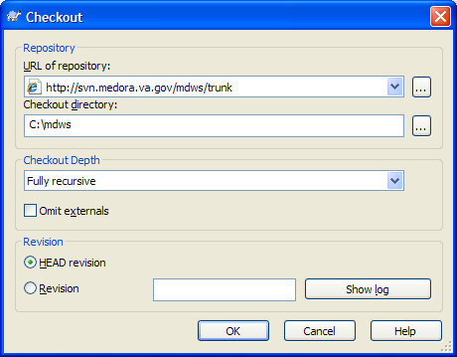
Screen capture of the Checkout window
- Type your Username and Password in the appropriate text boxes and click OK.
Note: If you have not done so already, request access to the Repository.
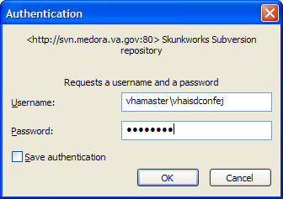
Screen capture of the Authentication window
- With successful checkout and authentication, the trunk – Checkout window displays.
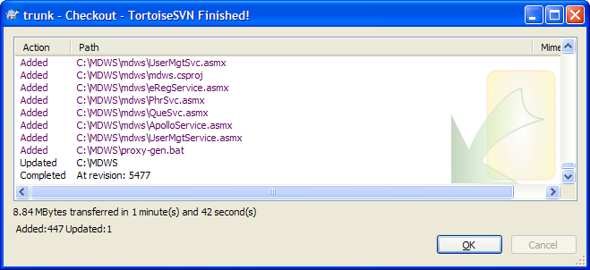
Screen capture of the trunk – Checkout window
- Click OK.
- On the Checkout window, right click the MDO folder, select SVN Checkout, and click OK.
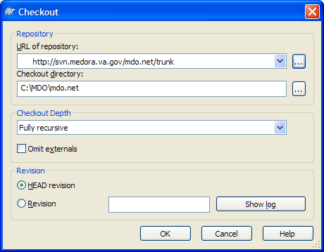
Screen capture of the Checkout window
- Repeat steps 5-8 for MDO specific directories.

Configuration Information

Directories
Application | Root | Functional Folder | Functional Folder | Sub-Folders
MDWS
 | MDWS
 |  | Properties
 |  | Src | dto
 |  |  | lib
 |  |  | partial
 |  |  | svc
 |  |  | resources
lib
xml
MDO
 | MDO
properties
resources
src
 |  |  | api  mdo  utils  dao | hl7
 |  |  |  | soap
sql
VistA
webservice
 |  |  |  | xml

MDWS Class Structure
- MDWS Web Service Classes
- Directory Path: directory mdws\src\svc\
- Purpose: The purpose of the web service classes are as a thin client pass through to the MDOs (medical data objects)
- Base Class: System.Web.Services.WebMethod
- Namespace: gov.va.medora.mdws
- MDWS DTO Classes
- Directory Path: mdws\src\dto\
- Purpose: These classes are to define abstract data types for the web services.
- Base Class: AbstractTO
- Namespace: gov.va.medora.mdws.dto
- MDWS Lib Classes
- Directory Path: mdws\src\lib\
- Purpose: These classes are used to match up a data type object and verify the connection.
- Base Class: None
- Namespace: gov.va.medora.mdws
- MDO API Classes
- Directory Path: mdo\src\api\
- Purpose: Execute the data request queries with a connection and parameters.
- Base Class: None
- Namespace: gov.va.medora.mdo.api
- MDO DAO Classes
- Directory Path: mdo\src\dao\
- Purpose: Provide interfaces for data access objects.
- Base Class: System.Collections
- Namespace: gov.va.medora.mdo.dao
- MDO MDO Classes
- Directory Path: mdo\src\mdo\
- Purpose: Defines data collections (Notes, Orders) and encapsulates business rules for the data.
- Base Class: None
- Namespace: gov.va.medora.mdo.mdo
- MDO Util Classes
- Directory Path: mdo\src\util\
- Purpose: Defines utility methods for use within MDO.
- Base Class: None
- Namespace: gov.va.medora.mdo.utils

Build Process
- To open Visual Studio Solution project, open the MDWS folder and double-click the mdws.sln file.
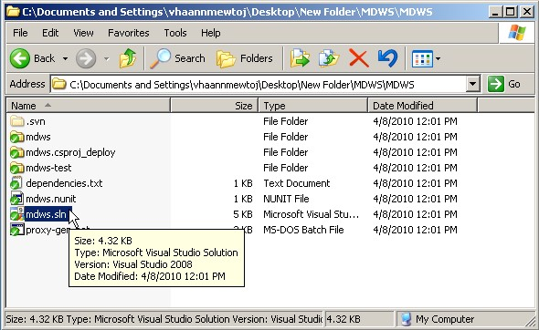
Screen capture of the C:\Documents and Settings window
- Your Visual Studio Solution project displays as in the following window.
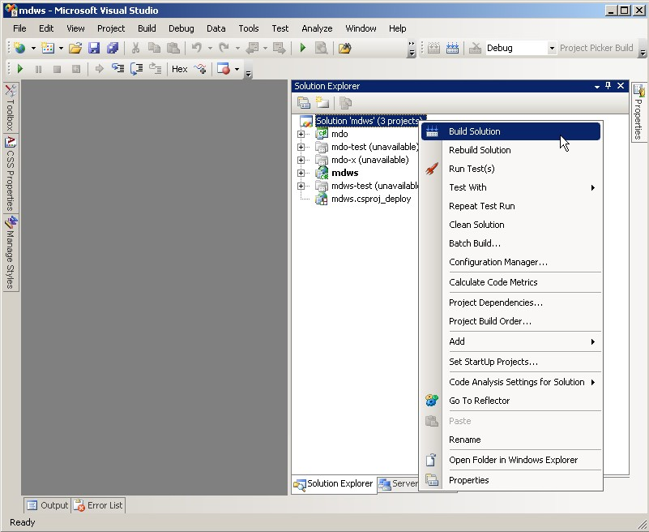
Screen capture of the mdws – Microsoft Visual Studio window
Solution Explorer
- In the Solution Explorer, right click the Solution 'mdws' text and select the Build Solution option.

- In Visual Studio at the bottom of the window, click the Output tab and look for the
Build: n succeeded or up-to-date, n failed, n skipped message.
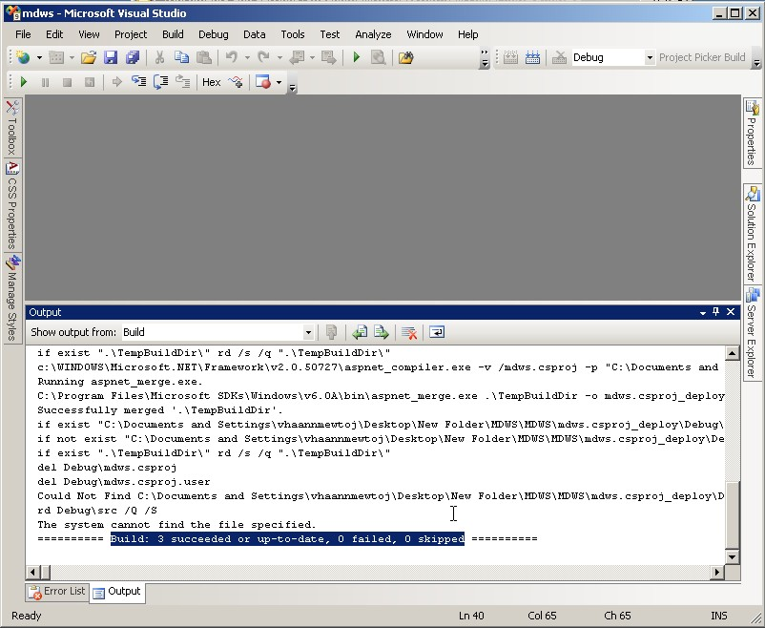
Screen capture of the mdws – Microsoft Visual Studio window
Output
- In the MDWS project folder, navigate to the mdws.csproj_deploy folder.
- To view the MDWS deployment files, open the Debug or Release folder.
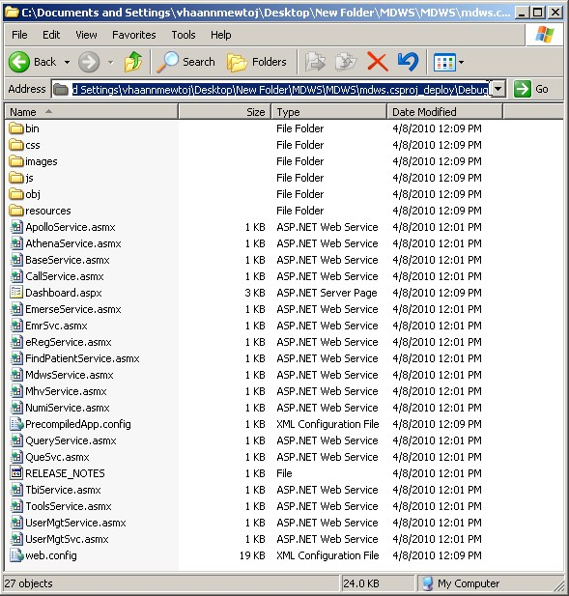
Screen capture of the C:\Documents and Settings window

Deploying the Project to IIS
Copy the files from step 6 to the C:\inetpub\wwwroot\mdws folder.

UDDI Services
Universal Description Discovery and Integration (UDDI) is an ‘advertising space’ for web services. The VA did not have any existing UDDI services, so the MDWS developers created a method for getting what MDWS can provide to other VA developers. The UDDI is at https://medora.va.gov/uddipublic/ and currently ‘advertises’ five MDWS web services, CallService, EmrSvc, FindPatientService, UserMgtSvc, and UtilMgtSvc.

To search the UDDI services, go to the URL.
- Click Search.
- Click the Services tab.
- Type in % wildcard and click Search.
All the services display in the left hand pane.

Instructions for publishing a new façade to UDDI are located at https://medora.va.gov/uddipublic/help/1033/publish.gettingstarted.aspx

Web Services
MDWS web services are organized into logical web method groupings within the system called facades.
An application uses a particular façade, depending on the applications type. For example, there are specific facades intended for care providers or call centers.
- If an application’s requirements do not match existing facades, new facades can quickly be set up (programmatically speaking) for new applications.
- Facades are a collection of thin pass-through calls to MDWS library classes. There is little programmatic logic within the web methods.

EmrSvc
The EmrSvc service will act as a façade for applications where the user is a health care provider.

Web Method | Library | Data Source
closeNote | NoteLib | VistA
cprsLaunch | ConnectionLib | VistA
cprsUserLookup | UserLib | VistA
getAdmissions | EncounterLib | VistA
getAdmissionsReports | EncounterLib | VistA
getAdvanceDirectives | NoteLib | VistA
getAllMeds | MedsLib | VistA
getAllergies | ClinicalLib | VistA
getAppointmentText | EncounterLib | VistA
getAppointments | EncounterLib | VistA
getAutopsyReports | LabsLib | VistA
getBloodAvailabilityReports | LabsLib | VistA
getBloodBankReports | LabsLib | VistA
getBloodTransfusionReports | LabsLib | VistA
getCareTeamReports | EncounterLib | VistA
getChemHemReports | LabsLib | VistA
getClinicalWarnings | NoteLib | VistA
getClinics | EncounterLib | VistA
getCompAndPenReports | EncounterLib | VistA
getConfidentiality | PatientLib | VistA
getConsultsForPatient | OrdersLib | VistA
getCrisisNotes | NoteLib | VistA
getCytologyReports | LabsLib | VistA
getCytopathologyReports | LabsLib | VistA
getDemographics |  | VistA
getDischargeDiagnosisReports | EncounterLib | VistA
getDischargeSummaries | NoteLib | VistA
getDischargesReports | EncounterLib | VistA
getDiscontinueReasons | OrdersLib | VistA
getElectronMicroscopyReports | LabsLib | VistA
getExpandedAdtReports | EncounterLib | VistA
getFutureClinicVisitsReports | EncounterLib | VistA
getHospitalLocations | EncounterLib | VistA
getIcdProceduresReports | EncounterLib | VistA
getIcdSurgeryReports | EncounterLib | VistA
getImagingReport | ClincalLib | VistA
getImmunizations | MedsLib | VistA
getIvMeds | MedsLib | VistA
getLatestVitalSigns | ClinicalLib | VistA
getLocations | EncounterLib | VistA
getMedicationDetail | MedsLib | VistA
getMedsAdminHx | MedsLib | VistA
getMedsAdminLog | MedsLib | VistA
getMicrobiologyReports | LabsLib | VistA
getNote | NoteLib | VistA
getNoteTitles | NoteLib | VistA
getNotesWithText | NoteLib | VistA
getOtherMeds | MedsLib | VistA
getOutpatientEncounterReports | EncounterLib | VistA
getOutpatientMeds | MedsLib | VistA
getOutpatientRxProfile | MedsLib | VistA
getPastClinicVisitsReports | EncounterLib | VistA
getPatientsByClinic | PatientsLib | VistA
getPatientsByProvider | PatientsLib | VistA
getPatientsBySpecialty | PatientsLib | VistA
getPatientsByTeam | PatientsLib | VistA
getPatientsByWard | PatientsLib | VistA
getPrfNoteActions | NoteLib | VistA
getProblemList | ClinicalLib | VistA
getRadiologyReports | ClinicalLib | VistA
getSignedNotes | NoteLib | VistA
getSpecialties | EncounterLib | VistA
getSurgeryReportText | ClinicalLib | VistA
getSurgeryReports | ClinicalLib | VistA
getSurgicalPathologyReports | LabsLib | VistA
getTeams | EncounterLib | VistA
getTransfersReports | EncounterLib | VistA
getTreatingSpecialtyReports | EncounterLib | VistA
getUncosignedNotes | NoteLib | VistA
getUnitDoseMeds | MedsLib | VistA
getUnsignedNotes | NoteLib | VistA
getVHA | SitesLib | VistA
getVISN | SitesLib | VistA
getVersion | NA | NA
getVisits | EncounterLib | VistA
getVitalSigns | VitalsLib | VistA
getWards | EncounterLib | VistA
isConsultNote | NoteLib | VistA
isCosignerRequired | NoteLib | VistA
isOneVisitNote | NoteLib | VistA
isPrfNote | NoteLib | VistA
isSurgeryNote | NoteLib | VistA
isValidEsig | UserLib | VistA
issueConfidentialityBulletin | PatientLib | VistA
match | PatientLib | VistA
mpiLookup | ConnectionLib | HL7
patientInquiry | PatientLib | VistA
saveH1N1Survey | H1N1SqlDao | SQL
select | PatientLib | VistA
signNote | NoteLib | VistA
writeNote | NotLib | VistA
writeSimpleOrderByPolicy | OrdersLib | VistA
visit200 | ConnectionLib

CallService
The Call service will act as the façade to develop call center applications.

Web Method | Library | Data Source
addDataSource | ConnectionLib | VistA
closeNote | NoteLib | VistA
connect | ConnectionLib | VistA
cprsUserLookup | UserLib | VistA
disconnect | ConnectionLib | VistA
getAdmissions | EncounterLib | VistA
getCitiesInState | SitesLib | VistA
getConsultsForPatient | TbiLib | VistA
getLocations | EncounterLib | VistA
getNearestFacility | SitesLib | VistA
getNoteTitles | NoteLib | VistA
getPrfNoteActions | NoteLib | VistA
getSite | SitesLib | VistA
getVHA | SitesLib | VistA
getVersion | NA | NA
getVhaByStates | SitesLib | VistA
getVisits | EncounterLib | VistA
isConsultNote | NoteLib | VistA
isCosignerRequired | NoteLib | VistA
isOneVisitNote | NoteLib | VistA
isPrfNote | NoteLib | VistA
isSurgeryNote | NoteLib | VistA
login | UserLib | VistA
match | PatientLib | VistA
matchByNameCityState | PatientLib | VistA
mpiLookup | PatientLib | HL7
select | NoteLib | VistA
signNote | NoteLib | VistA
visit | ConnectionLib | VistA
writeNote | NoteLib | VistA

NumiService
The Numi service will allow the tracking of inpatient bed movements.

Web Method | Library | Data Source
addDataSource | ConnectionLib | VistA
connect | ConnectionLib | VistA
connectAndLogin | UserLib | VistA
disconnect | ConnectionLib | VistA
getConfidentiality | PatientLib | VistA
getDRGRecords | EncounterLib | VistA
getInpatientDischarges | EncounterLib | VistA
getInpatientMoves | EncounterLib | VistA
getInpatientMovesByCheckinId | EncounterLib | VistA
getInpatientMovesByDateRange | EncounterLib | VistA
getInpatientMovesByDateTimeRange | EncounterLib | VistA
getStayMovements | EncounterLib | VistA
getStayMovementsByDateRange | EncounterLib | VistA
getStayMovementsByPatient | EncounterLib | VistA
getVHA | SitesLib | VistA
getVersion | NA | NA
getVistATimestamps | ConnectionLib | VistA
getWards | NumiLib | VistA
issueConfidentialityBulletin | PatientLib | VistA
login | UserLib | VistA
match | PatientLib | VistA
select | PatientLib | VistA
userLookup | UserLib | VistA
visit | ConnectionLib | VistA

TbiService
The Traumatic Brain Injury service is a facade intended for use with health care providers.

Web Method | Library | Data Source
addDataSource |  | VistA
closeNote | NoteLib | VistA
cprsLaunch | ConnectionLib | VistA
cprsUserLookup | UserLib | VistA
disconnectSite | ConnectionLib | VistA
getAdmissions | EncounterLib | VistA
getClinics | EncounterLib | VistA
getConsultsForPatient | TbiLib | VistA
getLocations | EncounterLib | VistA
getNoteText | NoteLib | VistA
getNoteTitles | NoteLib | VistA
getOefOif | PatientLib | VistA
getPatientsByClinic | PatientLib | VistA
getPatientsByWard | PatientLib | VistA
getPrfNoteActions | NoteLib | VistA
getVersion | EncounterLib | VistA
getVisits | EncounterLib | VistA
getWards | PatientLib | VistA
isConsultNote | NoteLib | VistA
isCosignerRequired | NoteLib | VistA
isOneVisitNote | NoteLib | VistA
isPrfNote | NoteLib | VistA
isSurgeryNote | NoteLib | VistA
signNote | NoteLib | VistA
writeNote | NoteLib | VistA
writeUnsignedNote | NoteLib | VistA

UserMgtScv
The User Management service will allow applications to manage VistA user accounts.

Web Method | Library | Data Source
addDataSource | ConnectionLib | VistA
addMenuOption | UserLib | VistA
addSecurityKey | UserLib | VistA
addSecurityKeyForContext | UserLib | VistA
connect | ConnectionLib | VistA
ddrLister | ToolsLib | VistA
disconnectSite | ConnectionLib | VistA
disconnectSites | ConnectionLib | VistA
getDelegatedOptions | UserLib | VistA
getGeographicLocations | SitesLib | VistA
getMenuOptions | UserLib | VistA
getSecurityKeys | UserLib | VistA
getSiteDivisions | EncounterLib | VistA
getUser | UserLib | VistA
getUserDUZBySSN | UserLib | VistA
getVHA | SitesLib | VistA
getVariableValue | ToolsLib | VistA
getVersion | NA | NA
login | UserLib | VistA
lookupByName | UserLib | VistA
lookupByNameMS | UserLib | VistA
removeMenuOption | UserLib | VistA
removeSecurityKey | UserLib | VistA
sendEmail | ToolsLib | VistA
visitSites | ConnectionLib | VistA

EmerseService
The Emerse service allows text searching of notes and reports.

Web Method | Library | Data Source
addDataSource | ConnectionLib | VistA
connect | ConnectionLib | VistA
cprsLaunch | ConnectionLib | VistA
disconnect | ConnectionLib | VistA
getAllMeds | MedsLib | VistA
getNotesWithText | NotesLib | VistA
getOutpatientRxProfile | MedsLib | VistA
getProblemList | ClinicalLib | VistA
getRadiologyReports | ClinicalLib | VistA
getVHA | SitesLib | VistA
getVersion | NA | NA
login | UserLib | VistA
match | PatientLib | VistA
mpiLookup | PatientLib | VistA
select | PatientLib | VistA
setupMultiSiteQuery | ConnectionLib | VistA
visit | ConnectionLib | VistA

FindpatientSvc
The Findpatient service will provide utilities for finding patients.

Web Method | Library | Data Source
addDataSource | ConnectionLib | VistA
connect | ConnectionLib | VistA
disconnectSite | ConnectionLib | VistA
disconnectSites | ConnectionLib | VistA
getFacilitiesForCounty | SitesLib | VistA
getSite | SitesLib | VistA
getVHA | SitesLib | VistA
getVersion | NA | NA
getVisnsForState | SitesLib | VistA
locatePatient | PatientLib | VistA
login | UserLib | VistA
matchByNameCityStateMS | PatientLib | VistA
matchCityAndState | SitesLib | VistA
mpiLookup | PatientLib | VistA
visitSites | ConnectionLib | VistA

MhvService
The Mhv service will allow patient health record (PHR) use cases.

Web Method | Library | Data Source
addDataSource | ConnectionLib | VistA
getAppointments | unimplemented | VistA
getAppointmentsFromSite | MhvLib | VistA
getChemHemReports | unimplemented | VistA
getChemHemReportsForPatientFromSite | unimplemented | VistA
getChemHemReportsFromSite | MhvLib | VistA
getDetailedRemindersFromSite | MhvLib | VistA
getFutureAppointments | unimplemented | NA
getFutureAppointmentsFromSite | unimplemented | VistA
getSummaryRemindersFromSite | MhvLib | VistA
getVersion | NA | NA

AthenaService
The Athena service will provide the ability to launch from CPRS Tools menu, and connect, authenticate, select patient given DUZ, DFN, or site code.

Web Method | Library | Data Source
addDataSource | ConnectionLib | VistA
cprsLaunch | ConnectionLib | VistA
disconnect | ConnectionLib | VistA
getLatestVitalSigns | VitalsLib | VistA
getLocations | AthenaLib | VistA
getNoteTitles | NoteLib | VistA
getVersion | NA | NA
setupMultiSiteQuery | ConnectionLib | VistA
writeUnsignedNote | NoteLib | VistA

UserMgtService
The User Management service will allow a user to access a single VistA system given SSN, DUZ, site code, and user/pass

Web Method | Library | Data Source
addDataSource | ConnectionLib | VistA
connectSite | ConnectionLib | VistA
cprsUserLookup | UserLib | VistA
disconnectSite | ConnectionLib | VistA
getUserInfo |  | VistA
getVHA | SitesLib | VistA
getVersion | NA | NA
login | UserLib | VistA
lookup | UserLib | VistA
visitSite | ConnectionLib | VistA

MDO
Most of the heavy lifting in MDWS happens in Medical Data Objects (MDO). The MDWS libraries call one of the API’s listed in the \api folder of MDO.

The API is the implementation of one of the web methods.
- The API implementation takes the parameters from MDWS, a new instantiation of the MDO objects (in \mdo ), and passes everything along to the data access objects in the \dao folder.
- The Data Access Objects (DAO) contain the specifics on where to connect and what to connect to, in order to provide the data elements for MDO.
Note: MDO is both the project name and the general term to name the set of objects, but most of the work to populate a particular medical data object with meaningful data takes place inside the different DAO classes. These rules are depicted in Figure A.1, however the NHIN portion may not make the initial national release of MDWS. While the figure below shows business rules as a distinct portion similar to the API, the rules are implemented as a natural part of the rest of the system and not part of a distinct and separate code base with distinct objects.
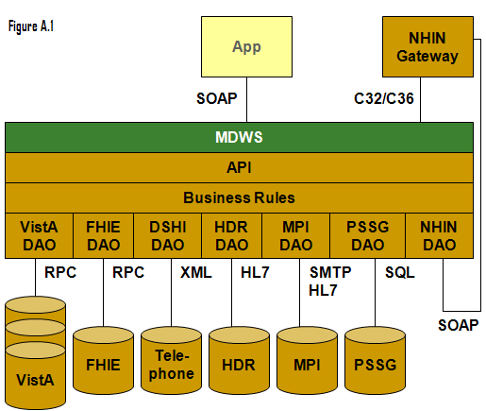

Representation of MDO depicting the implementation of business rules

Troubleshooting MDWS

Uninstalling MDWS
- Click Start.
- Select Control Panel.
- Double-click Add or Remove Programs.
- Select MDWS.
- Click Remove.
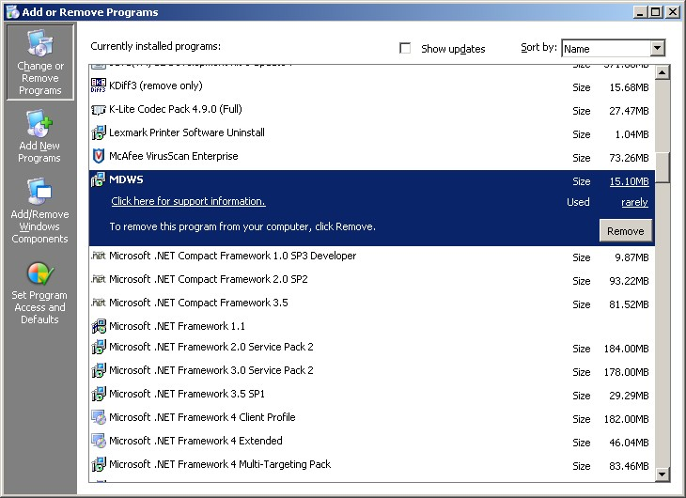
Control Panel>Add or Remove Programs

Normal Procedures
In general, to troubleshoot any problem, check the following sources:
- Browse to the local web services and make sure the Web Service Definition Language (WSDL) displays.
- Run the connection test page.

Sample of an Error Message
from MDWS to a requesting client application

<?xml version="1.0" encoding="utf-8" ?>
- <TaggedInpatientStayArray xmlns:xsi="http://www.w3.org/2001/XMLSchema-instance" xmlns:xsd="http://www.w3.org/2001/XMLSchema" xmlns="http://mdws.medora.va.gov/EmrSvc">
- <fault>
<type />
<message>There are no open connections</message>
<stackTrace />
<suggestion />
</fault>
<count>0</count>
</TaggedInpatientStayArray>

Production Issue History
MDWS has never had a production problem. MDWS shared an application pool at the C3 level with VistAWeb. Problems with the VistAWeb application caused a brief loss of connectivity for MDWS clients, until IIS was restarted.

Future productions issues are to be added to this document in the following table.

Date | Cause | Resolution

Potential Troubleshooting Steps
- In IIS, recycle the application pool in which MDWS resides.
- Restart IIS.
- Look for server events or server changes (anti-virus, group policies, etc.).

Failover MDWS Deployment
The client application(s) are responsible for pointing to a failover MDWS deployment and is not directly related to restoring a failed MDWS instance. The client can accomplish the failover in two ways: automated and manual.

Automated Solution
The automated solution is more complex from a software development standpoint, but has the advantage of being a near instantaneous resolution to a primary MDWS failure.

In an automated failover environment, when the primary endpoint no longer responds to requests, the client application switches from the primary well known MDWS endpoint to a well known backup or failover MDWS endpoint.
- It is imperative the client application support team is made aware a switch was made to a backup service.
- The client application developer must architect this notification into their software.

Manual Solution
In a manual failover environment, when the primary well known MDWS endpoint becomes unavailable,
the client application developer must manually modify their code or configuration files.
- The client application support team can be made aware of the failure automatically by including code that notifies the necessary personnel when the primary MDWS instance becomes unavailable.
- The client application support team usually settles on the simplest solution, which is to wait for users to report the failure. Then the support team begins troubleshooting, determines the failure is MDWS related, and points the client application to a well-known failover endpoint.

Symptoms, Diagnoses, and Possible Solutions
Symptom
MDWS WSDL not viewable locally
http://localhost/mdws/CallService.asmx
404 Page Not Found
Diagnoses and Solutions
IIS Default web site configuration likely incorrect
Symptom
This room left blank intentionally for future solutions
Diagnoses and Solutions
This room left blank intentionally for future solutions
Symptom
This room left blank intentionally for future solutions
Diagnoses and Solutions
This room left blank intentionally for future solutions
Symptom
This room left blank intentionally for future solutions
Diagnoses and Solutions
This room left blank intentionally for future solutions
Symptom
This room left blank intentionally for future solutions
Diagnoses and Solutions
This room left blank intentionally for future solutions
Symptom
This room left blank intentionally for future solutions
Diagnoses and Solutions
This room left blank intentionally for future solutions
Symptom
This room left blank intentionally for future solutions
Diagnoses and Solutions
This room left blank intentionally for future solutions
Symptom
This room left blank intentionally for future solutions
Diagnoses and Solutions
This room left blank intentionally for future solutions

Glossary
Term | Definition
AITC | Austin Information Technology Center
AViVA | A Virtual Instance of VistA Architecture
BHIE | Bi-directional Health Information Exchange
BMS | Bed Management Solutions
Caché | An ‘M’ based product (by InterSystems) which has been selected as the next generation VistA platform
CAPRI | Compensation and Pension Records Interchange
C1 | Class 1
C3 | Class 3
CCOW | Clinical Context Object Workgroup
Client Applications | Client applications can be written in Delphi. Visual Basic, C#, HTML/Javascript, PHP, etc.
COM | Component Object Model
Connectivity | Connectivity provides connection to the Master Patient Index (MPI), Structured Query Language (SQL) and Extensible Markup Language (XML).
COTS | Commercial Off the Shelf
CPRS | Computerized Patient Record System
DAO | Data Access Objects
DFN | Data File Number  A patient’s local identifier, the internal entry number in file #2
DHS | Department of Homeland Security
DICOM | Digital Imaging and Communication in Medicine
DUZ | A user’s local identifier, the internal entry number in file #200
EIE | Enterprise Infrastructure Engineering
ESSENCE | Electronic Surveillance System for the Early Notification of Community-based Epidemics
Façade | A set of useable features made available for applications of a certain type. Each façade is a partial class composed of methods from multiple source libraries combined in a logical grouping for the consumer type (e.g., Patient, Provider, Util)
FIPS | Federal Information Processing Standard
GOTS | Government Off The Shelf
GUI | Graphical User Interface
HAIISS | Healthcare Associated Infection and Influenza Surveillance System
HDR | Health Data Repository
HL7 | Health Level 7
ICD | International Classification of Diseases
ICN | The patient’s national identifier, Integration Control Number
IDE | Integrated Development Environment
IEN | Internal Entry Number
J2EE | Java 2 Platform, Enterprise Edition defines the standard for developing multitier enterprise applications
MDO | Medical Domain Objects  MDO is the middle-tier SOA used by MDWS to access multiple VistA sites without further credentialing, which works entirely through existing Remote Procedure Calls (RPCs)
MDWS | Medical Domain Web Services
MPI | Master Patient Index
MRI | Magnetic Resonance Imaging
MSI | Microsoft Installer (file)
MWSV | NameSpace assigned to Medical Domain Web Services (MDWS) by DBA
.NET | The Microsoft .NET Framework is a software framework that can be installed on computers running Microsoft Windows operating systems
NOK | Next Of Kin
NUMI | National Utilization Management Integration
OEF | Operation Enduring Freedom
OIF | Operation Iraqi Freedom
PHR | Patient Health Re cord
PSSG | Planning System Support Group
RPC | Remote Procedure Call
RSD | Requirements Specification Document
SIA | Security Integration Agreement
SMTP | Simple Mail Transfer Protocol
SOA | Service Oriented Architecture is a flexible set of design principles used during the phases of systems development and integration. A deployed SOA-based architecture will provide a loosely integrated suite of services that can be used within multiple business domains.
SOAP | Server Oriented Architecture Protocol
SQL | Structured Query Language
TIU | Text Integration Utility
UDDI | Universal Description, Discovery and Integration  A registry that enables a developer to shop for MDWS pre-fabricated web services
VA | Department of Veterans Affairs
VAMC | Department of Veterans Affairs Medical Center
VHA | Veterans Health Administration
VistA | Veterans Health Information Systems and Technology Architecture  An enterprise-wide information system built around an electronic health record used throughout the Department of Veterans Affairs medical system.
VW | VistA Web
VWS | VistA Web Services
WSDL | Web Service Description Language (WSDL) is a document that provides a common language to describe:  what the web service does  what functionality it can provide  what data it can deliver  A developer can click WSDL and generate the code automatically.
XML | Extensible Markup Language

